>1

> cal – prints calendar

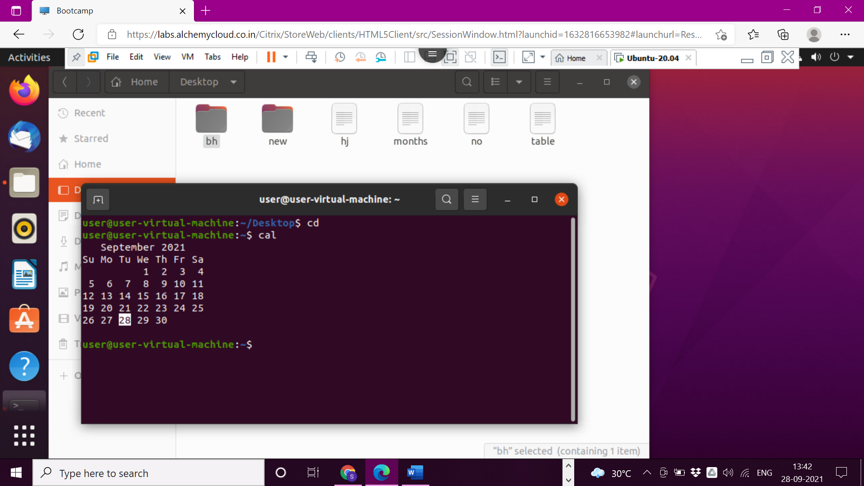

>2

>date – date command used to print date

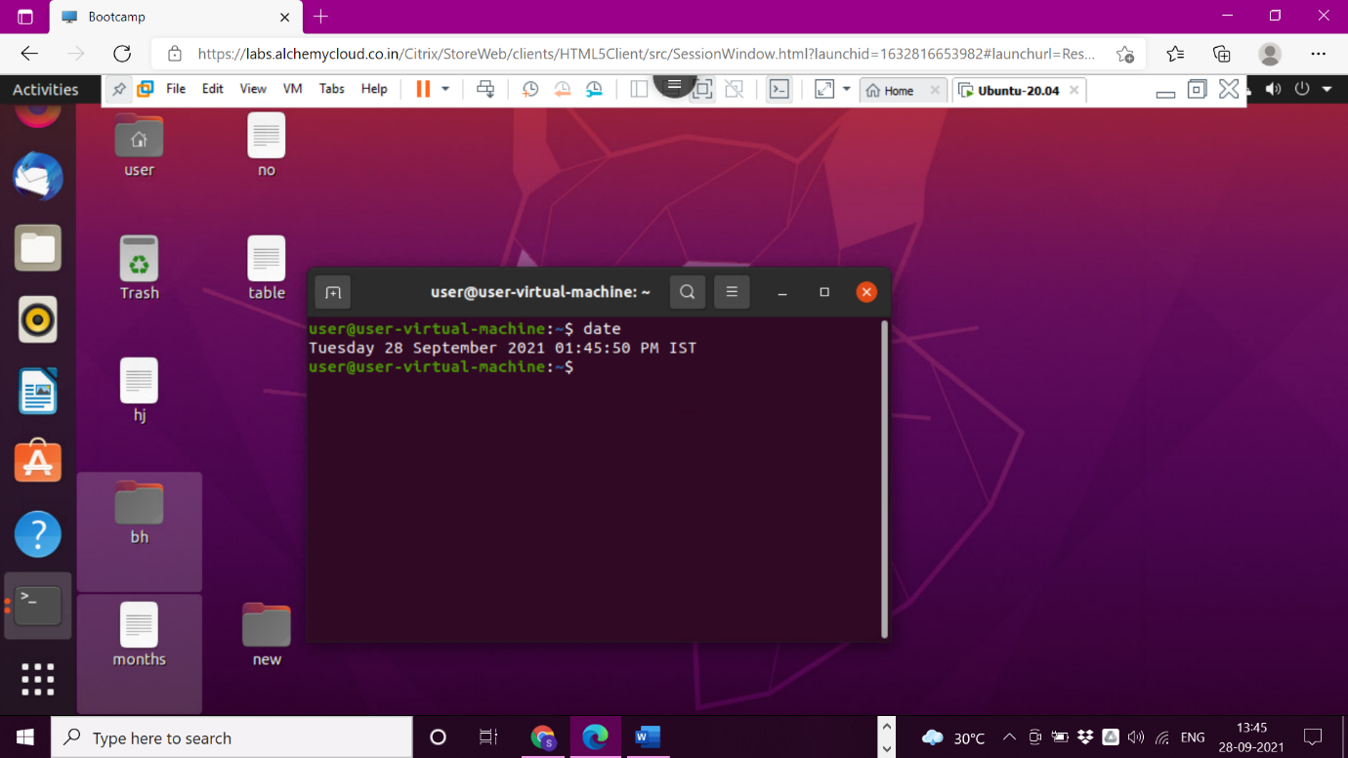

>3

> sort command – prints in dictionary order

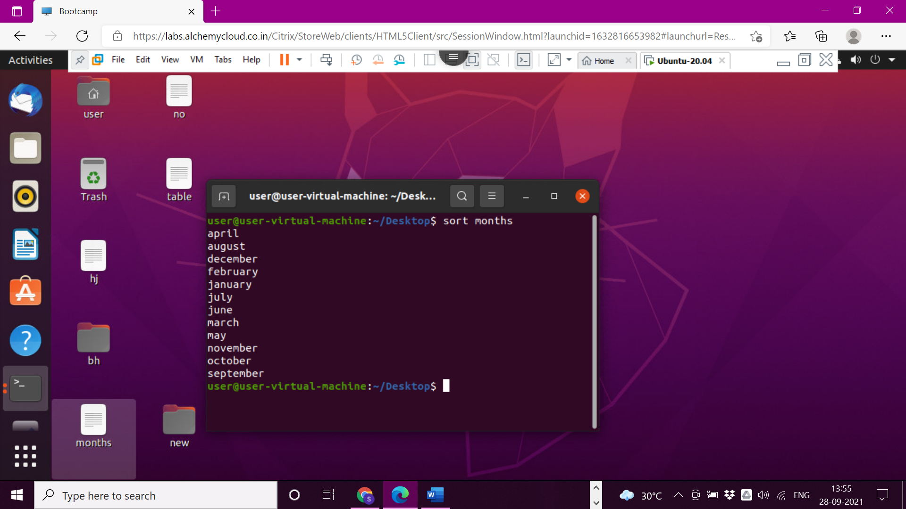

>4

> -m command – to sort months in order.

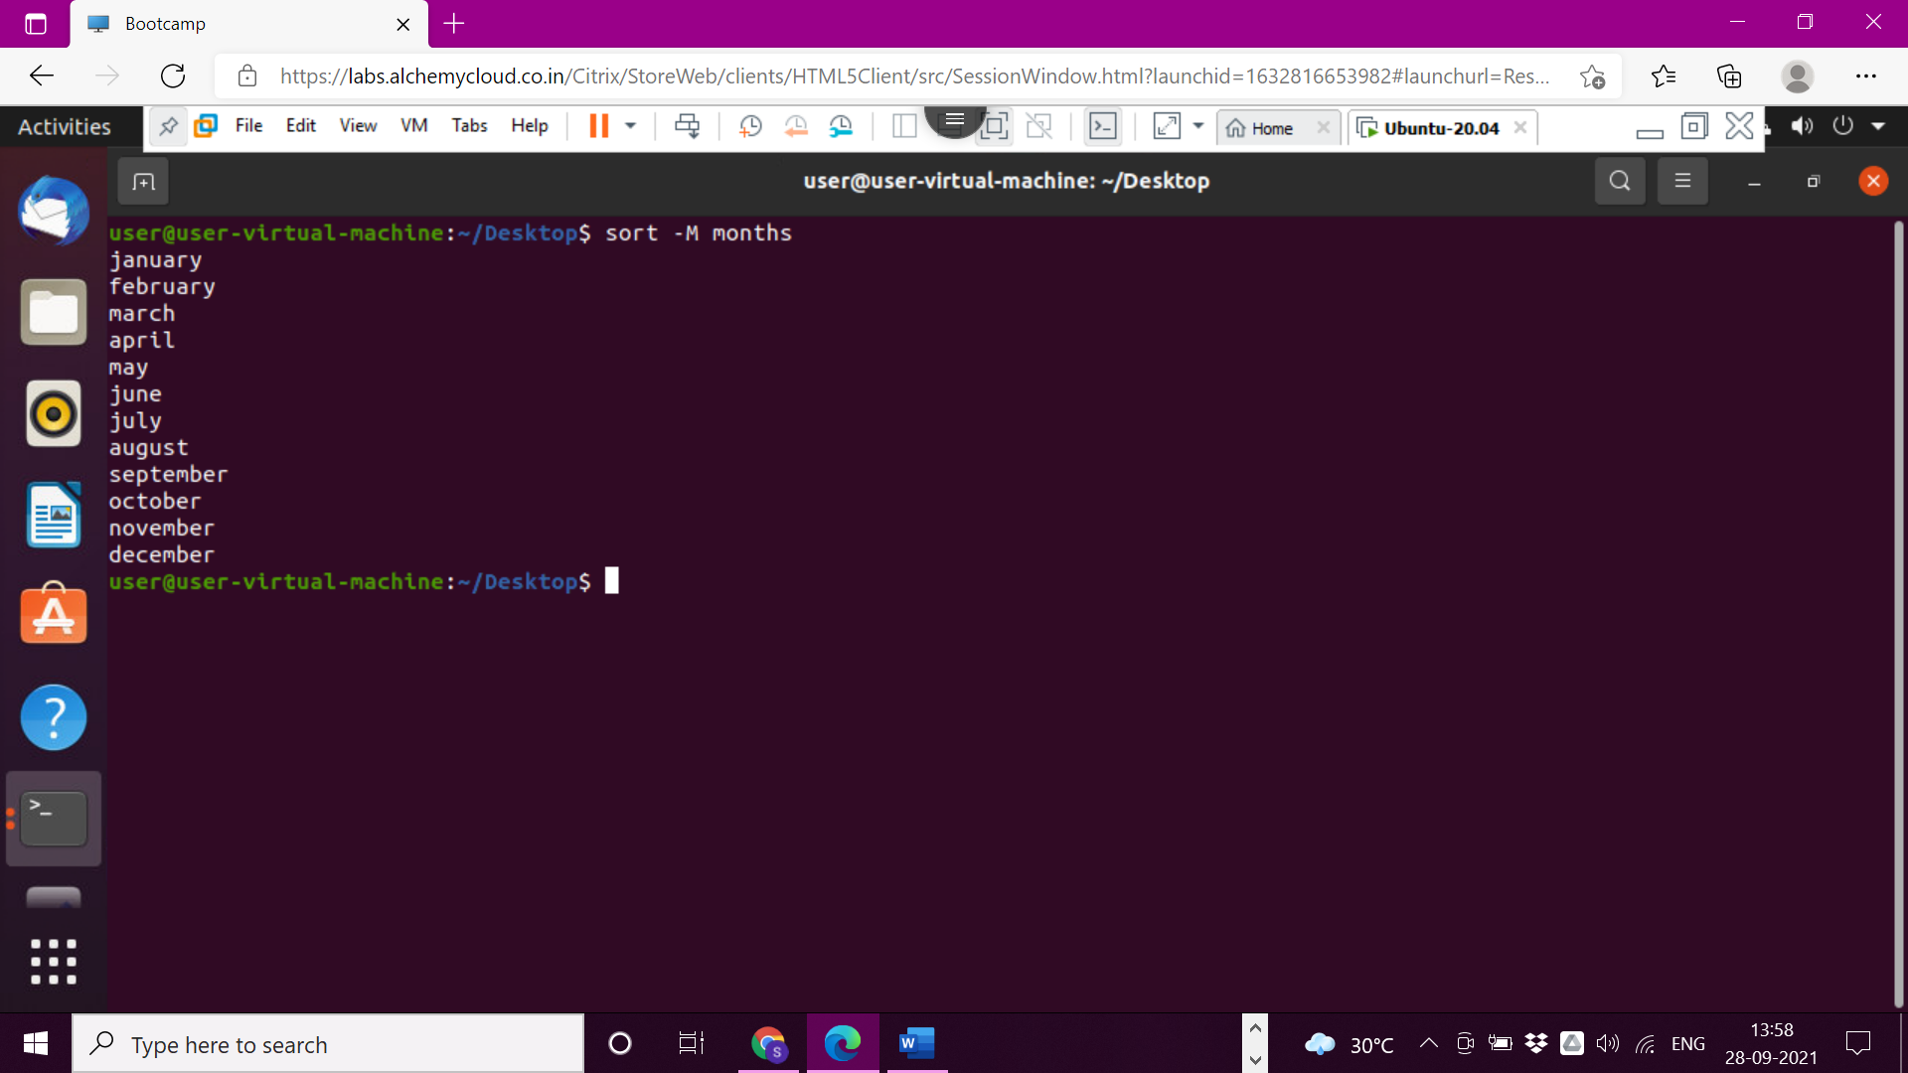

>5

> -k command for sorting table as column wise

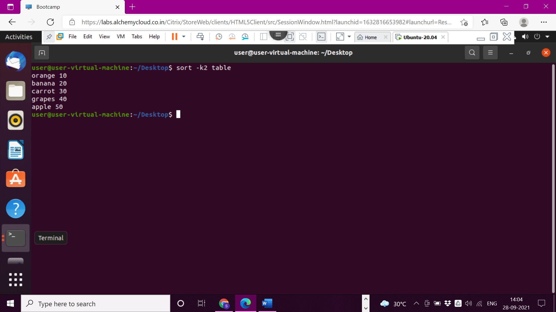

>6

>-r command for writing table in reverse order by using column name

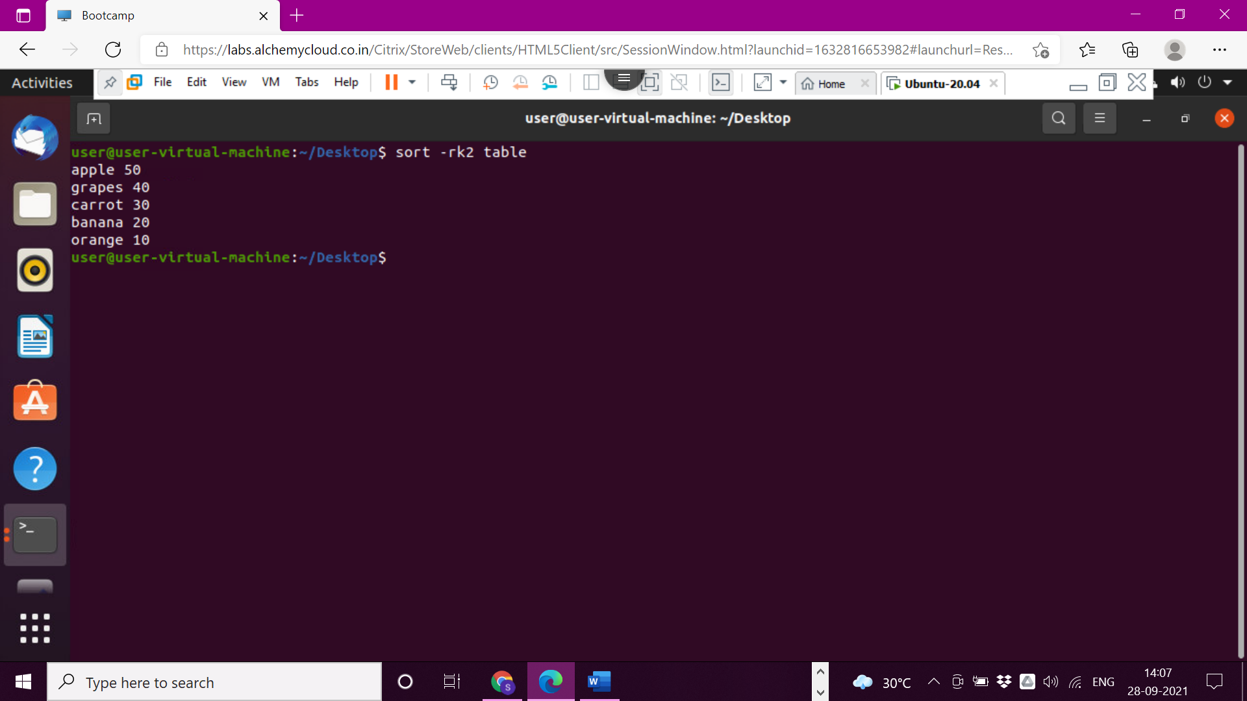

>7

> -n command for sorting numbers in order

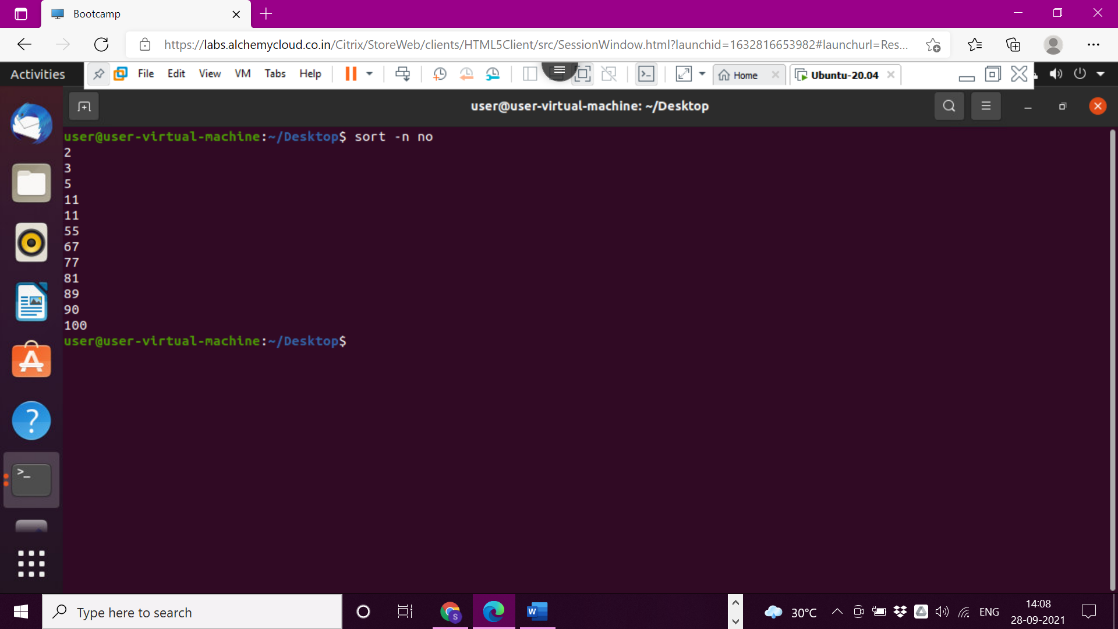

>8

> -nr command for sorting numbers in reverse order

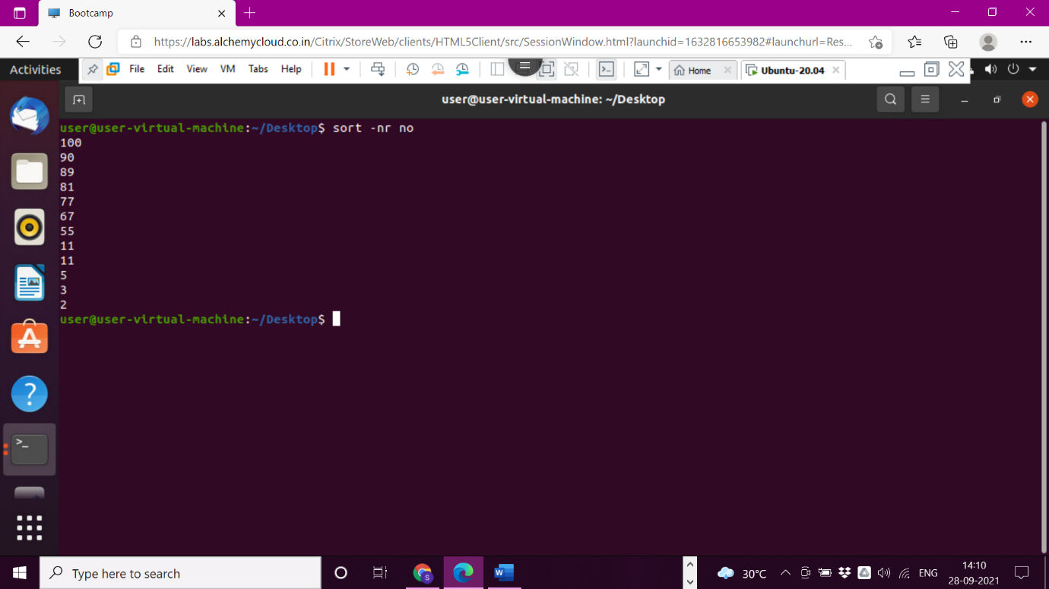

>9

>mv command for moving source file into destination file by deleting content and file of source file

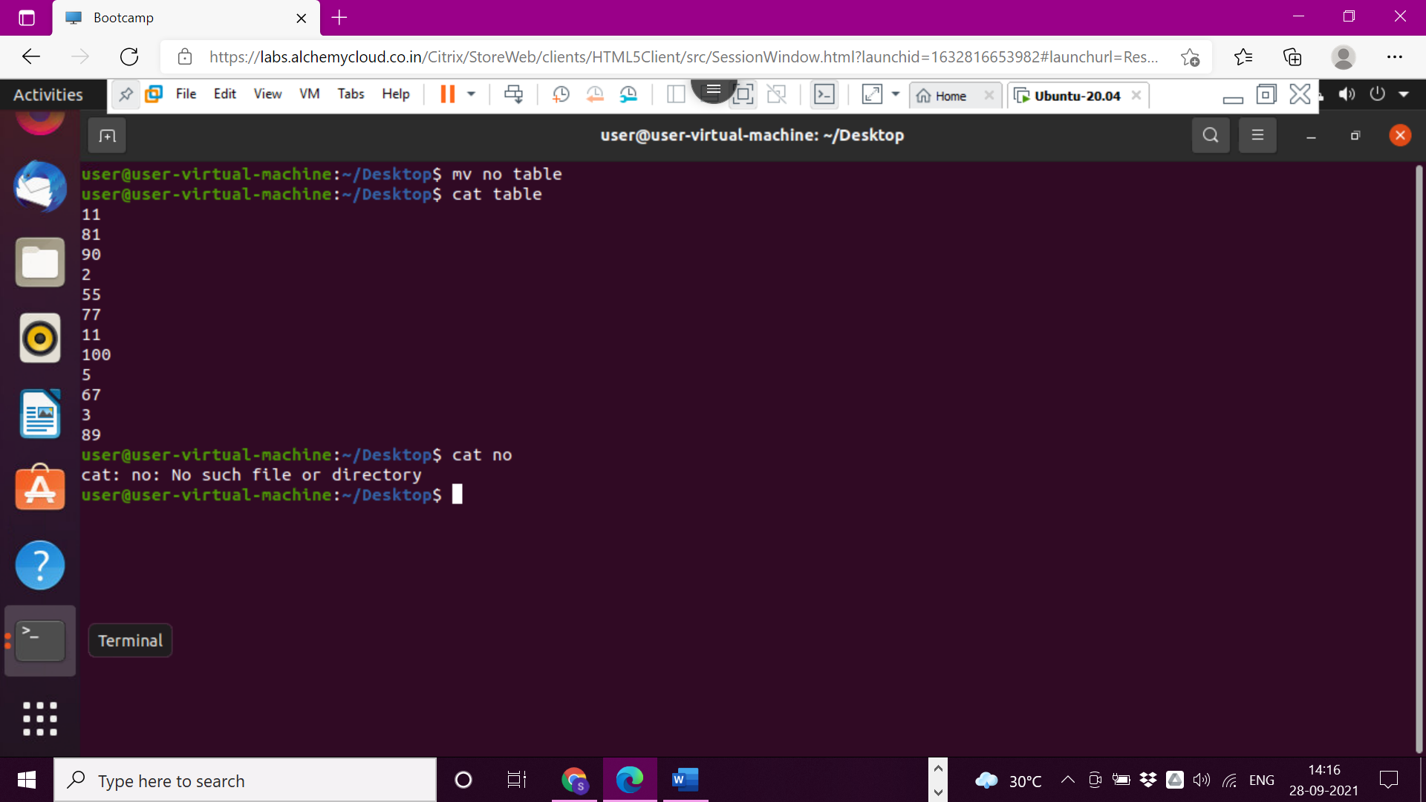

>10

> -b command used to create backup file while moving source file into destination file. The backup file is used to represent with (~) symbol.

We can access backup file

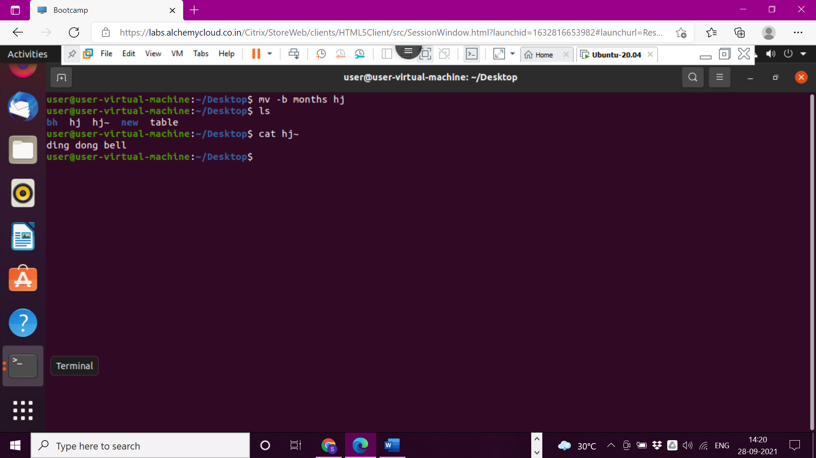

>11

>mv command for moving file from one data location to another

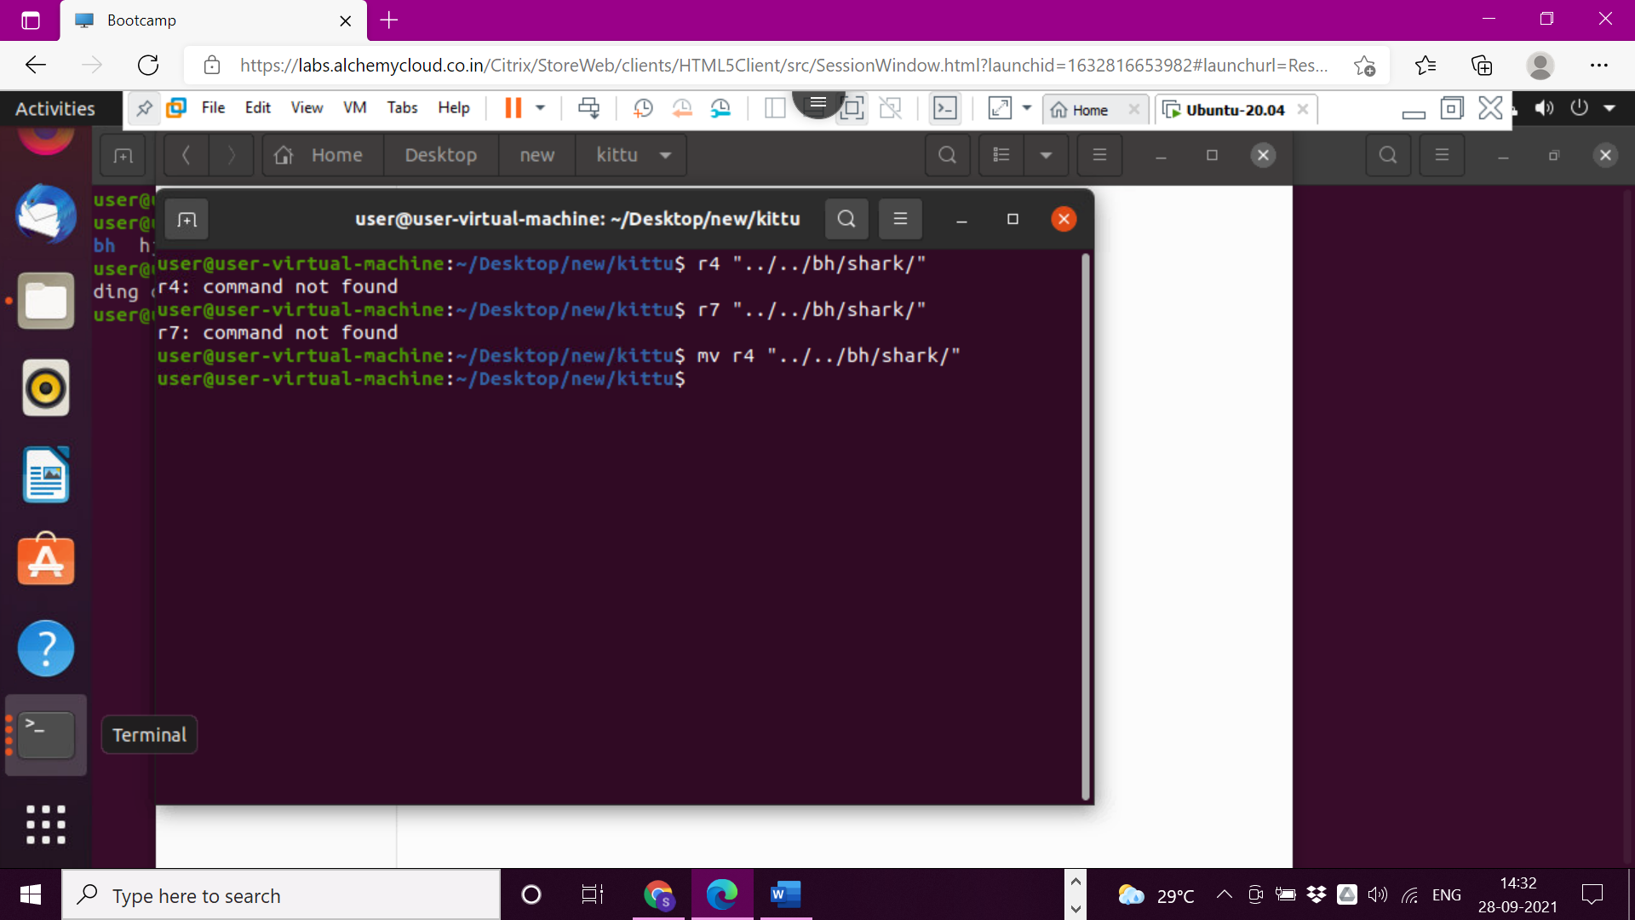

>12

>cp command for copying one folder into another folder

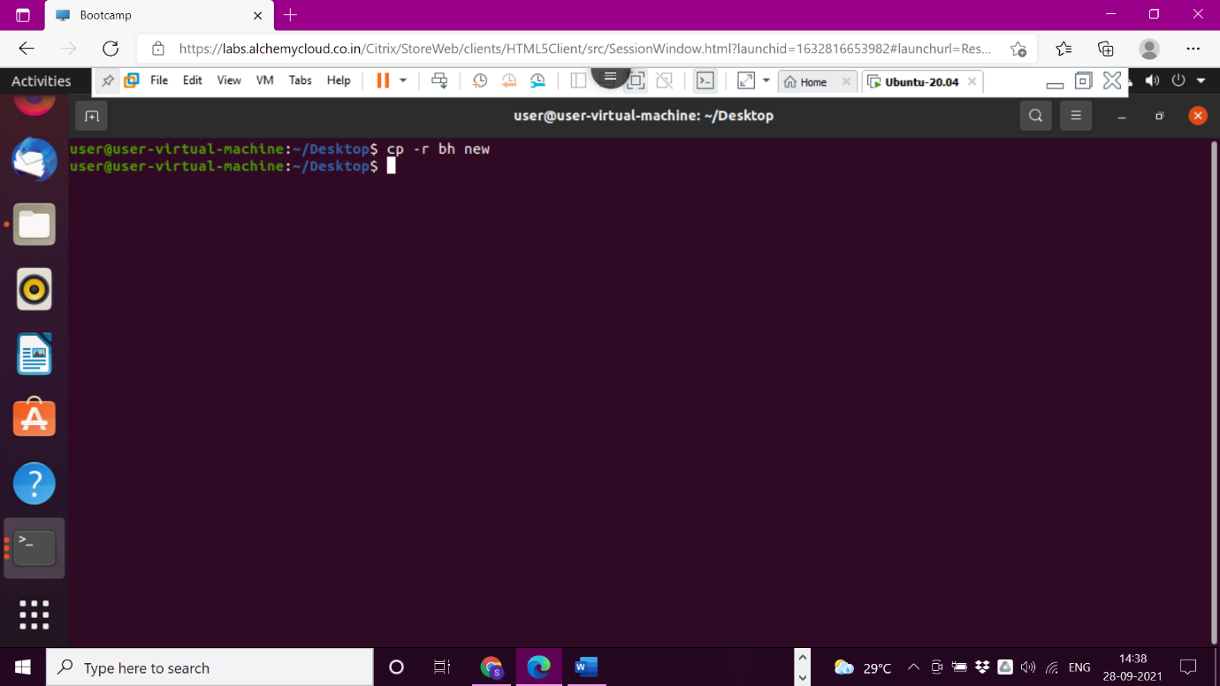

>13

>cp command for copying two text files

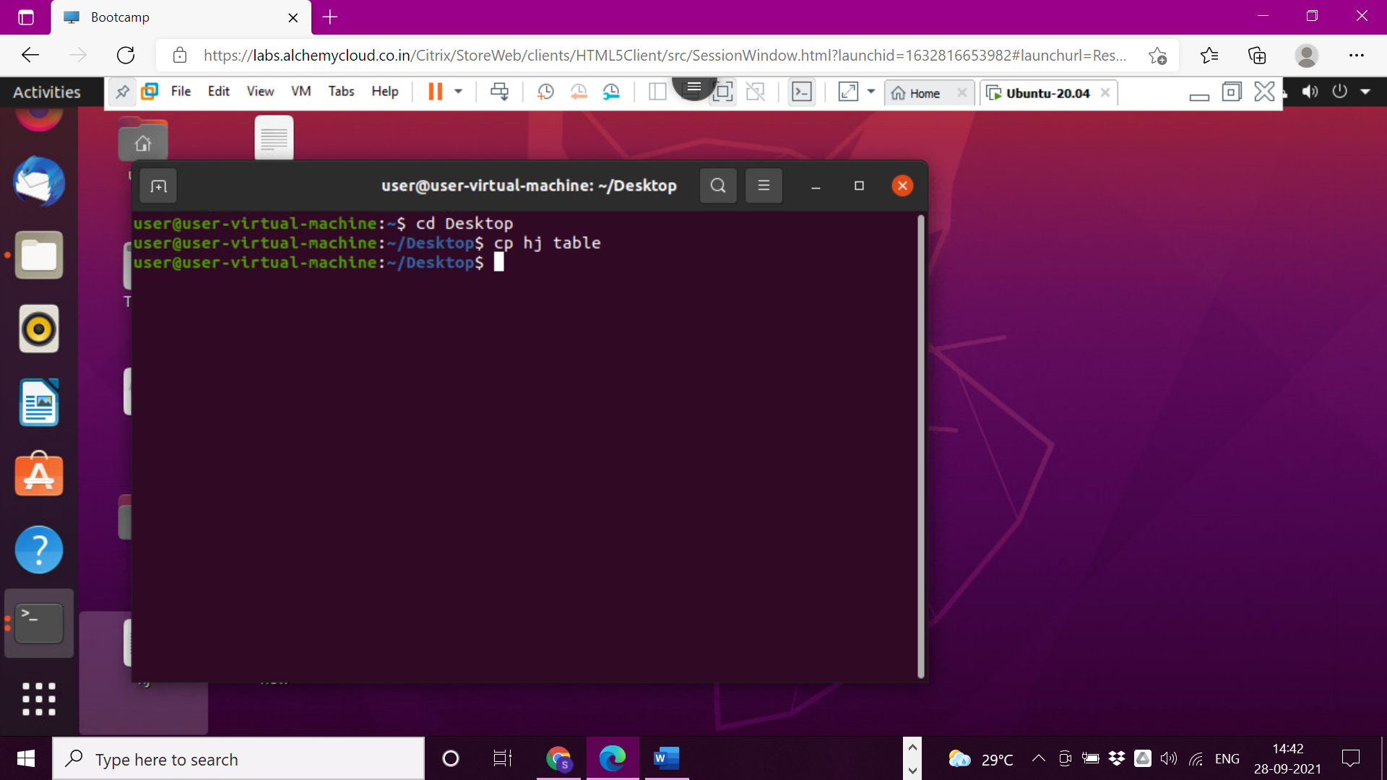

>14

>cp command for copying two text files into one folder

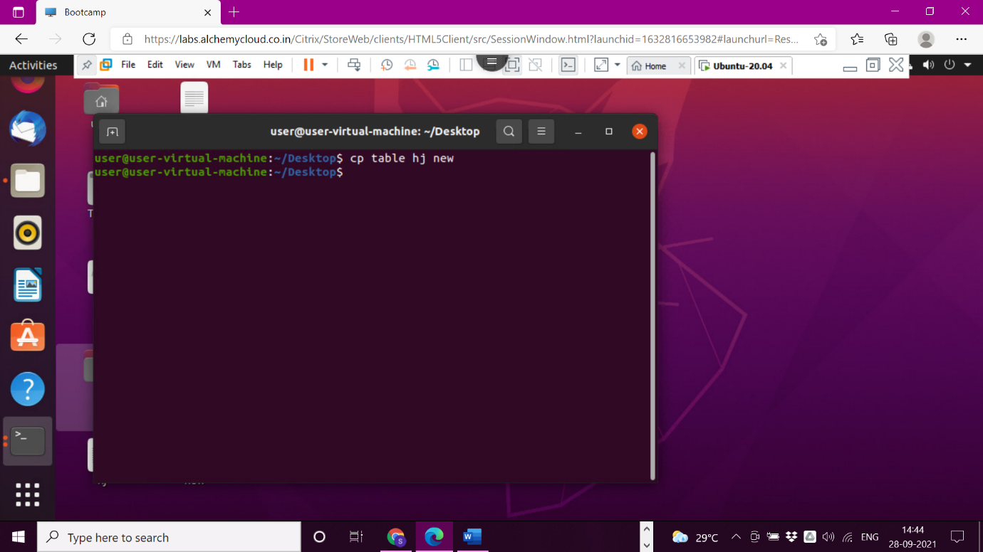

>15

>cat command for copying two text files into another file

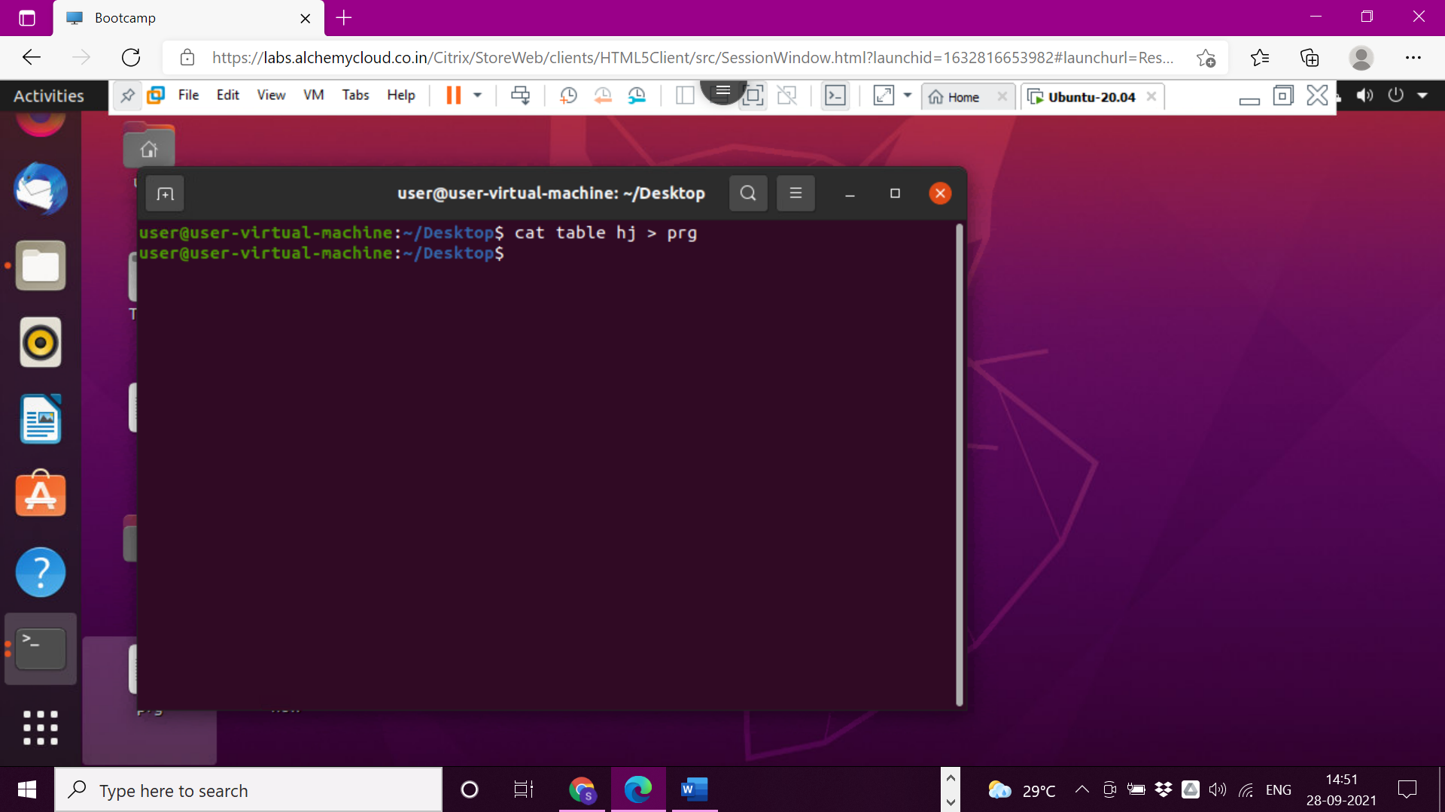

>16

> -i command for copying one file into another file gives warning as should I override destination file with source file

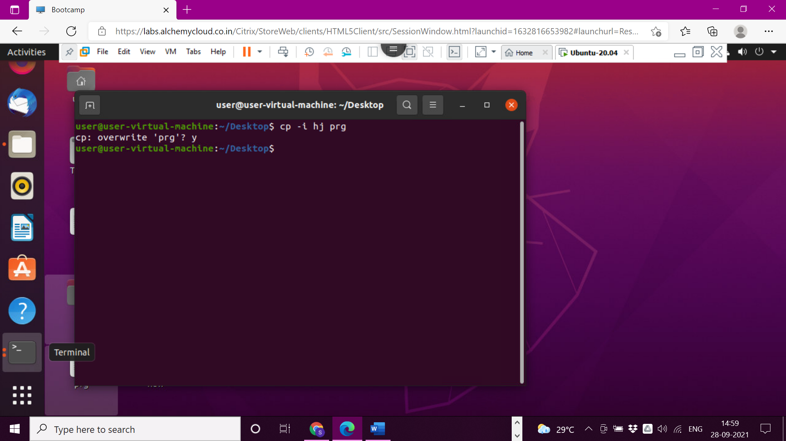

>17

>mkdir – make directory

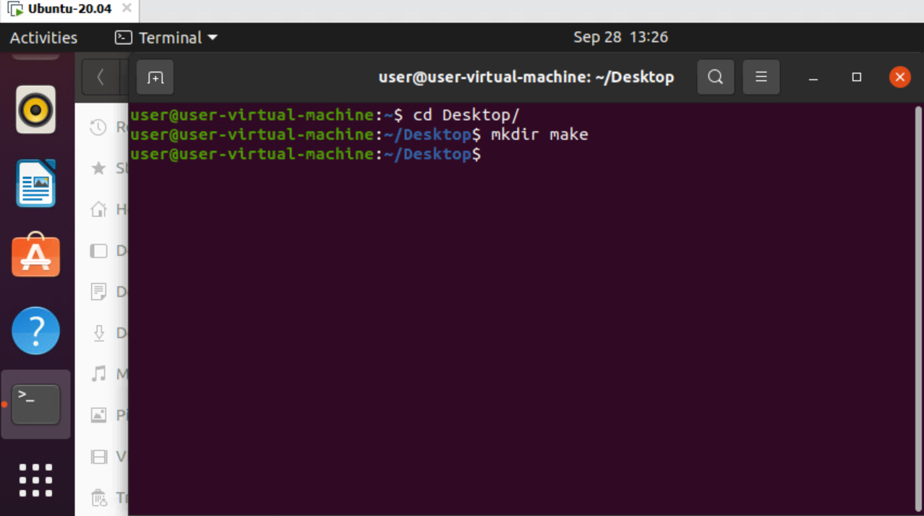

>18

>mkdir – create multiple file

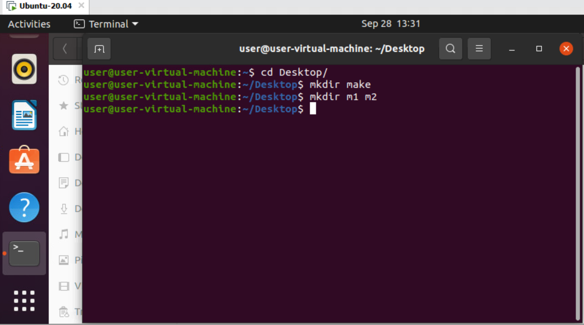

>19

>mkdir ‘’ – name with spaces.

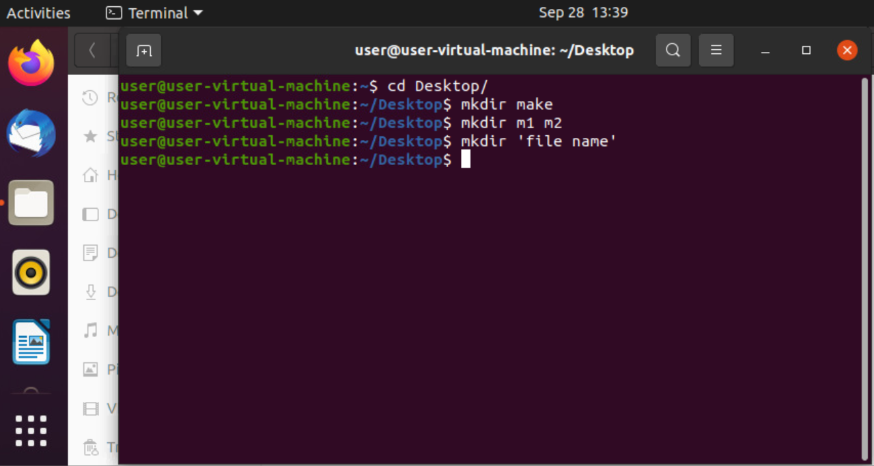

>20

>mkdir filename{1..n} – many number directories.

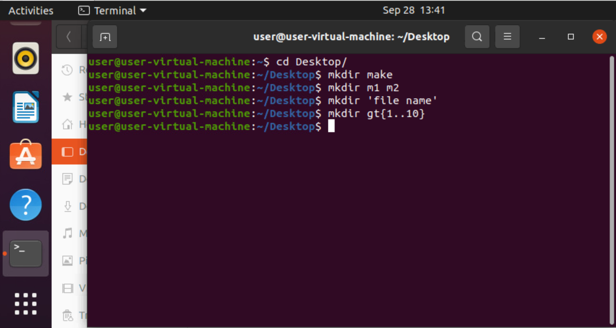

>21

>mkdir -p f/f/f – directory in directory.

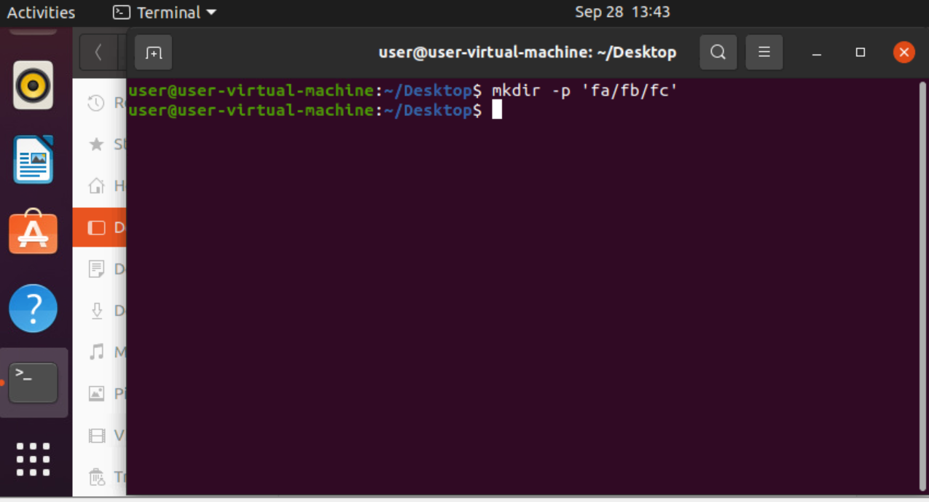

>22

>rmdir – removes empty directory.

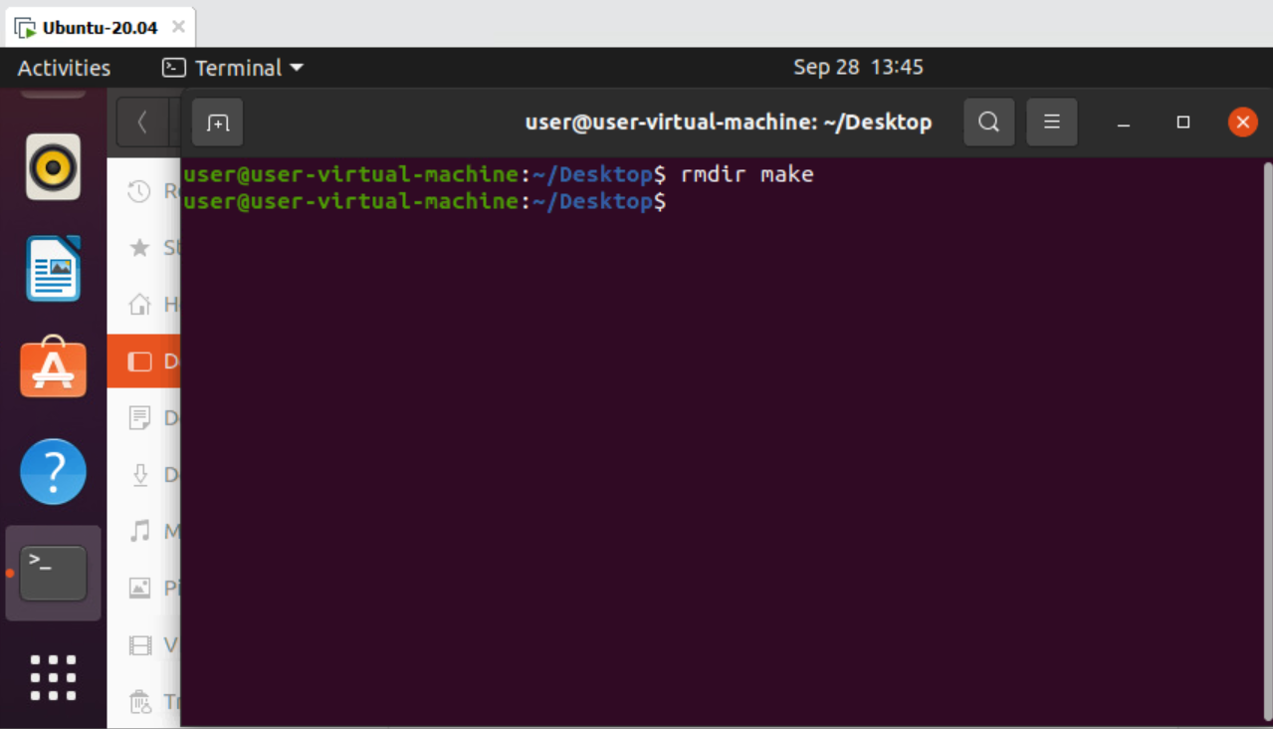

>23

>rm -r dname – removes non empty directory.

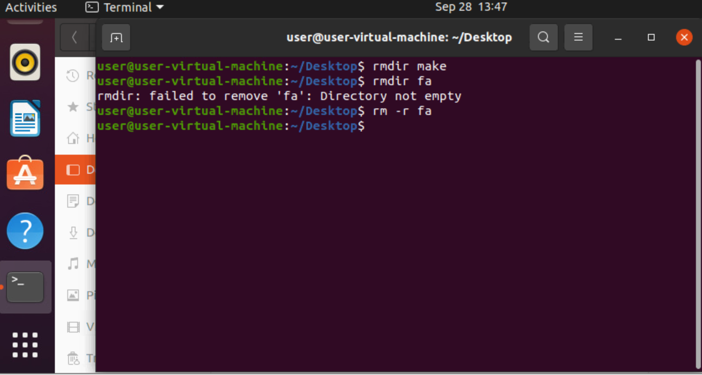

>24

>mkdir ‘a ‘{1..n} – name with spaces.

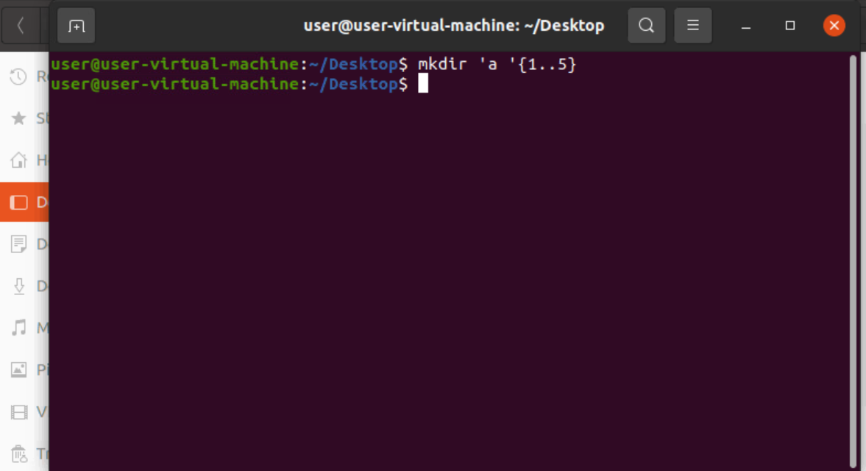

>25

>rm ‘folder/f.txt’ – remove file from a folder

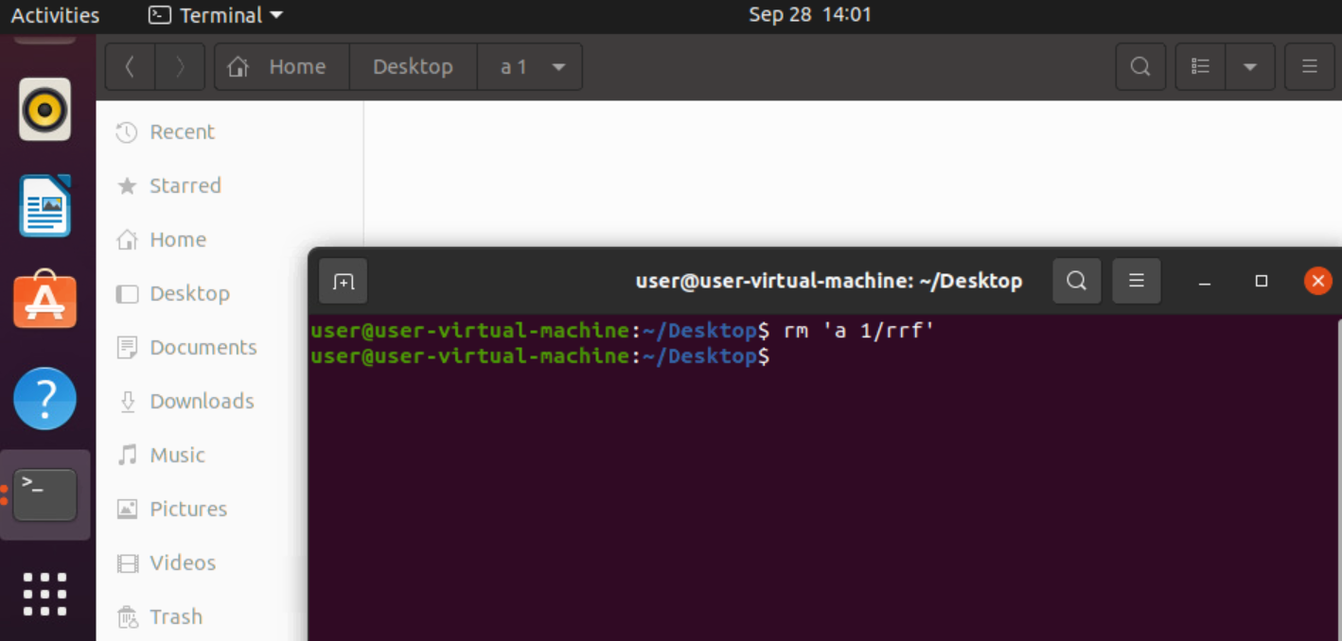

>26

>touch filename – create empty file.

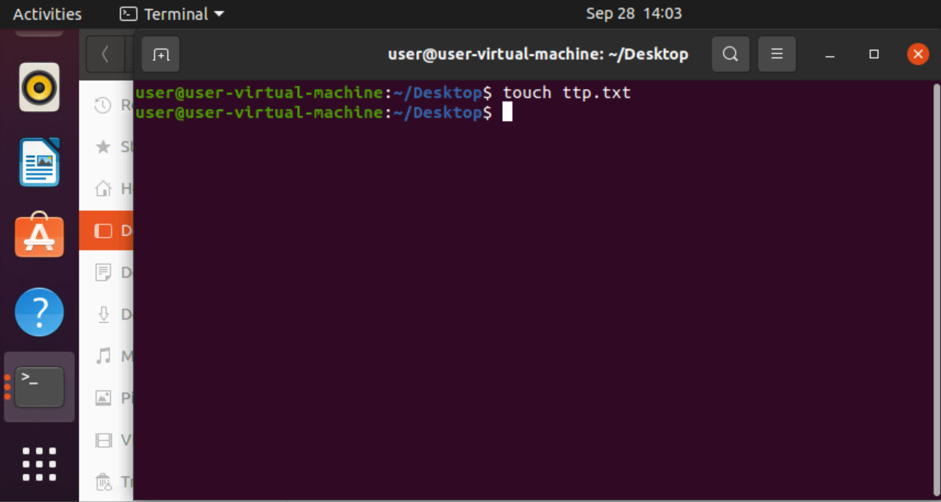

>27

>touch f1 f2…. – creates multiple files.

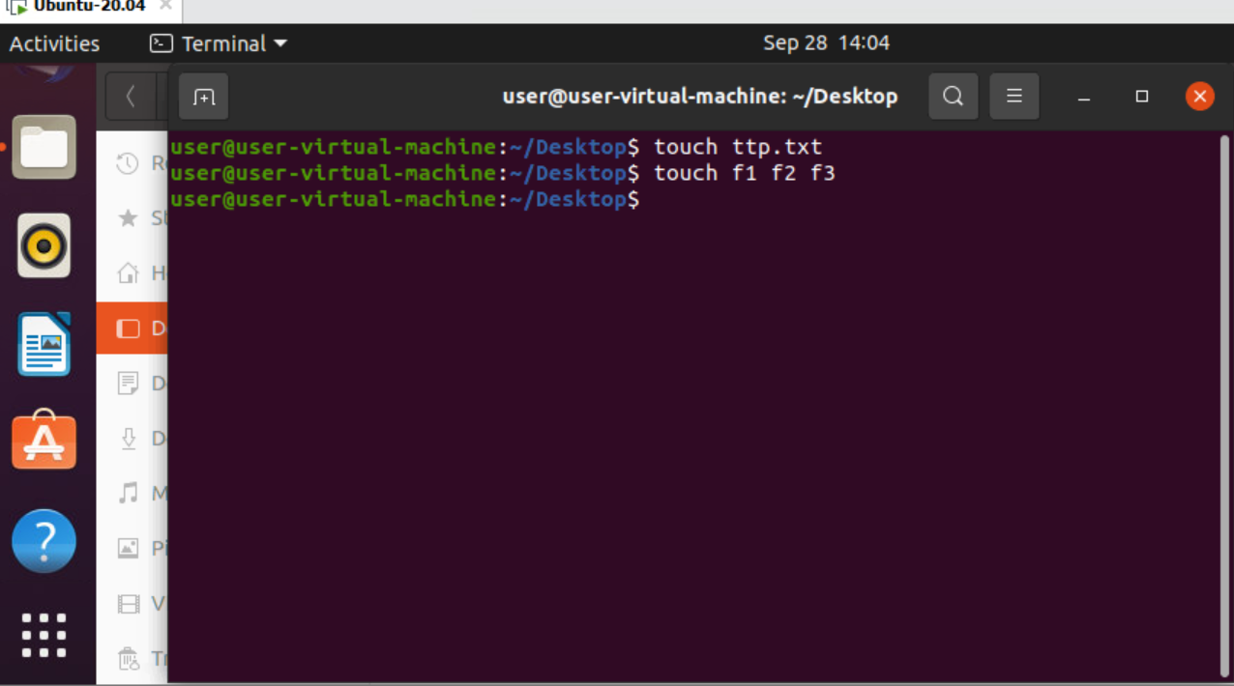

>28

>rm fname – removes file

>29

>rm \*.txt – removes extension files

>30

>rm \* - removes all files.

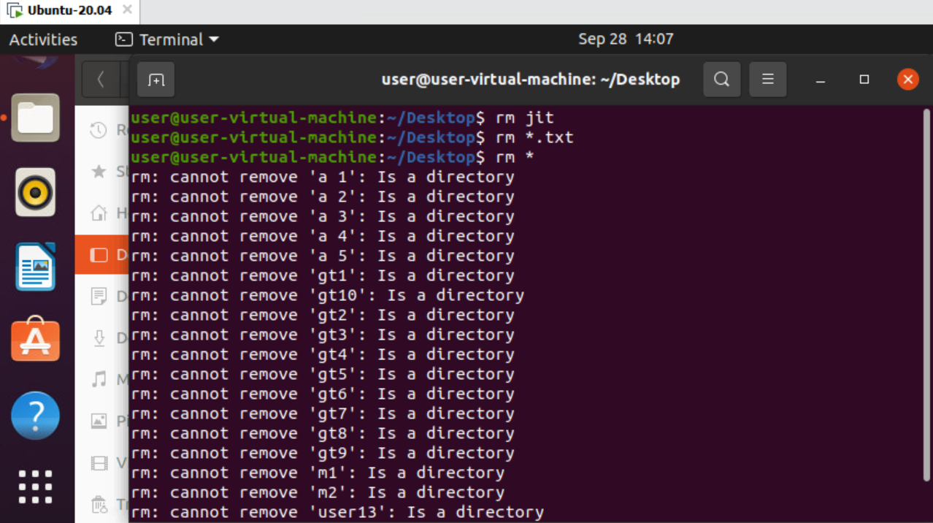

>31

>touch -c filename – checks presence of file.

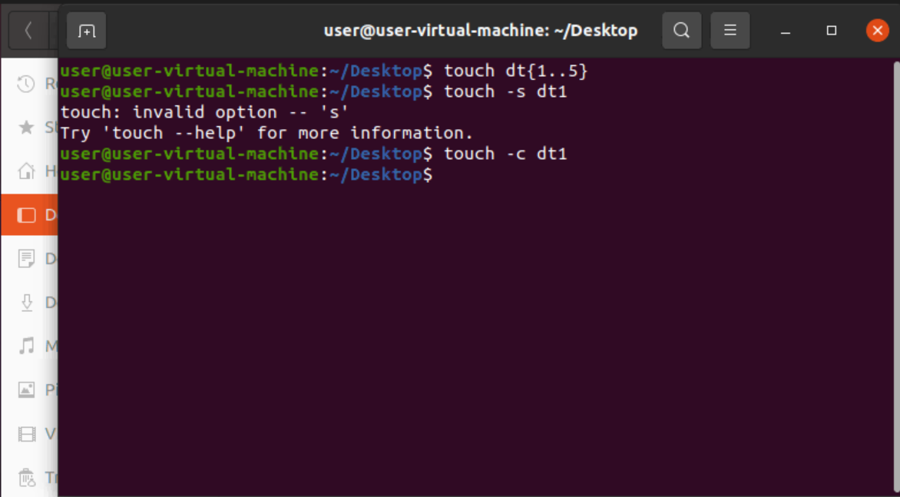

>32

>echo “hello there” > f – file with content.

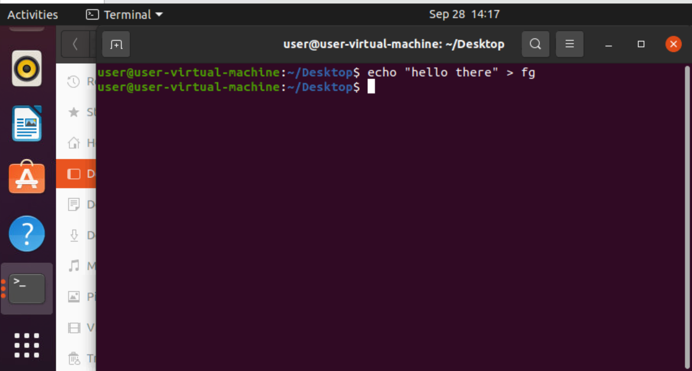

>33

>cp f1 f2 – copies file1 to file2.

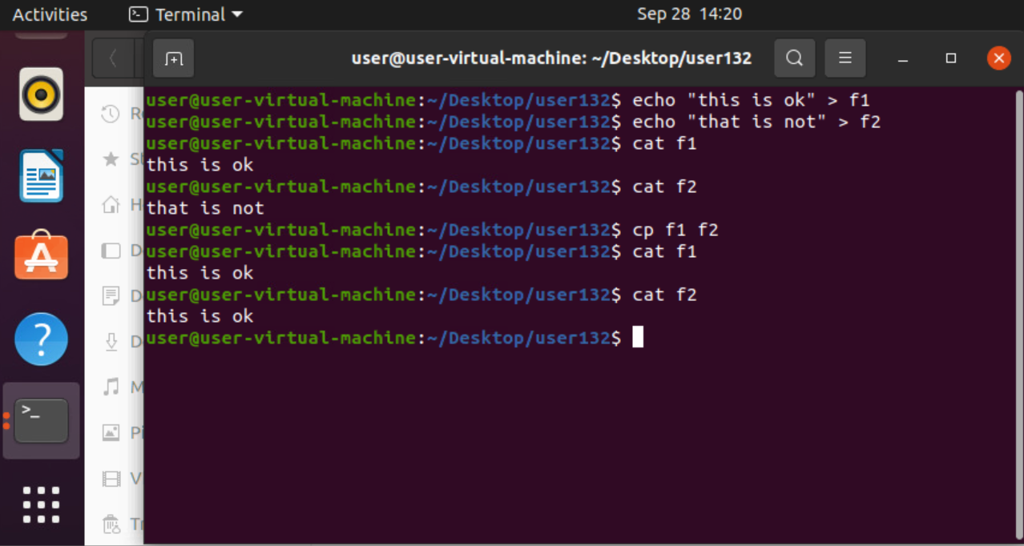

>34

>opening text file using gedit

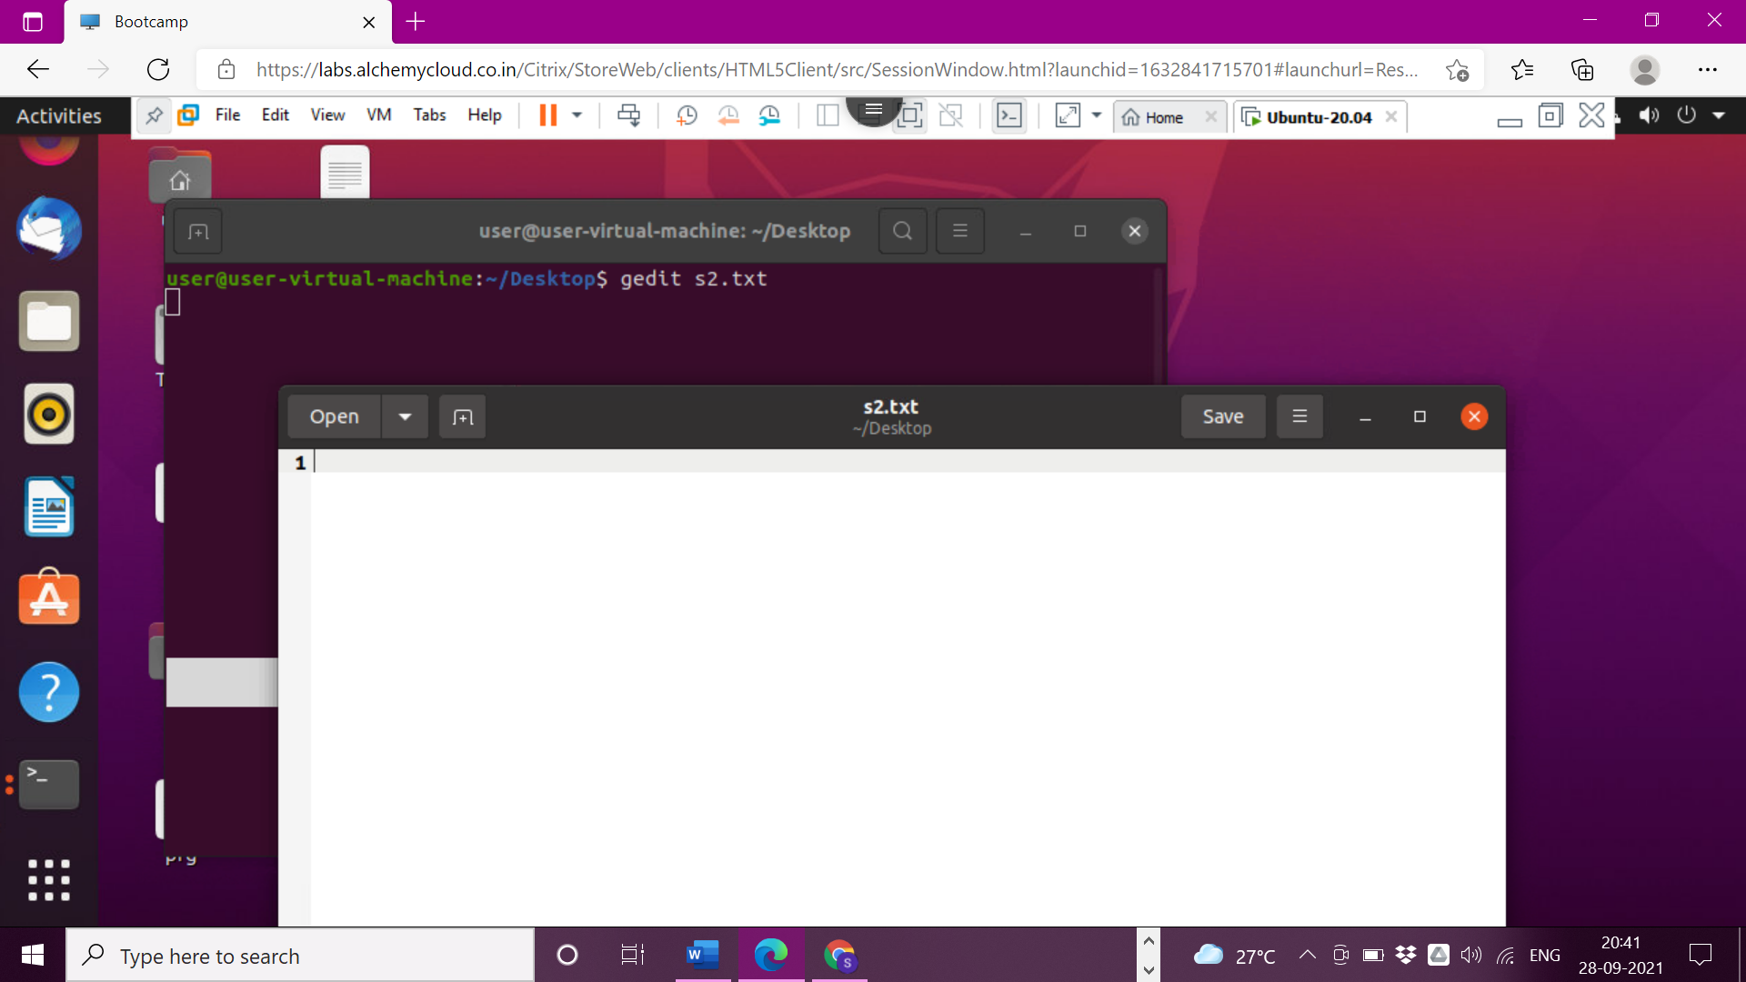

>35

>Vim command

